**Jenkins Task 2** Date : 27-08-2024

**1) Configure 2 slave machines in jenkins master.**

Steps to be done on slave

===================

Login to slave machine..

switch to root user

install jdk 11 (amazon-linux-extras install java-openjdk11)

Create ssh-keygen

cat id_rsa.pub > authorized_keys

chmod 700 authorized_keys

Steps to be done on master machine:

===========================

Login to master machine

switch to root user.

mkdir -p /var/lib/jenkins/.ssh

cd /var/lib/jenkins/.ssh

ssh-keyscan -H SLAVE-NODE-IP-OR-HOSTNAME >>/var/lib/jenkins/.ssh/known_hosts

# ssh-keyscan -H 172.31.38.42 >>/var/lib/jenkins/.ssh/known_hosts

chown jenkins:jenkins known_hosts

#we need to change the owner as we ran ssh-keyscan command using “root” user.

# default user of Jenkins will be “jenkins”

chmod 700 known_hosts

# DOne !!

Steps to be done on jenkins GUI:

========================

Go to manage jenkins

open manage node

under launch method select "Launch via SSh"

Host "public ip of slave"

creditals: select user with private key

enter ec2-user as name and paste the pem key.

host key verification startegy to be selected

save..

we are good with the master and slave configuration

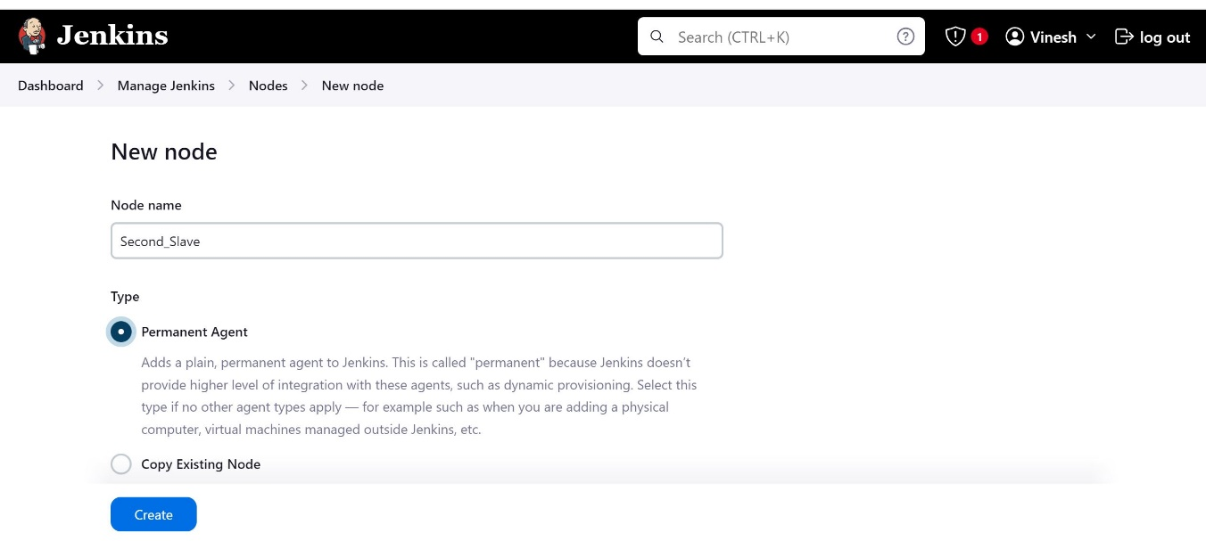

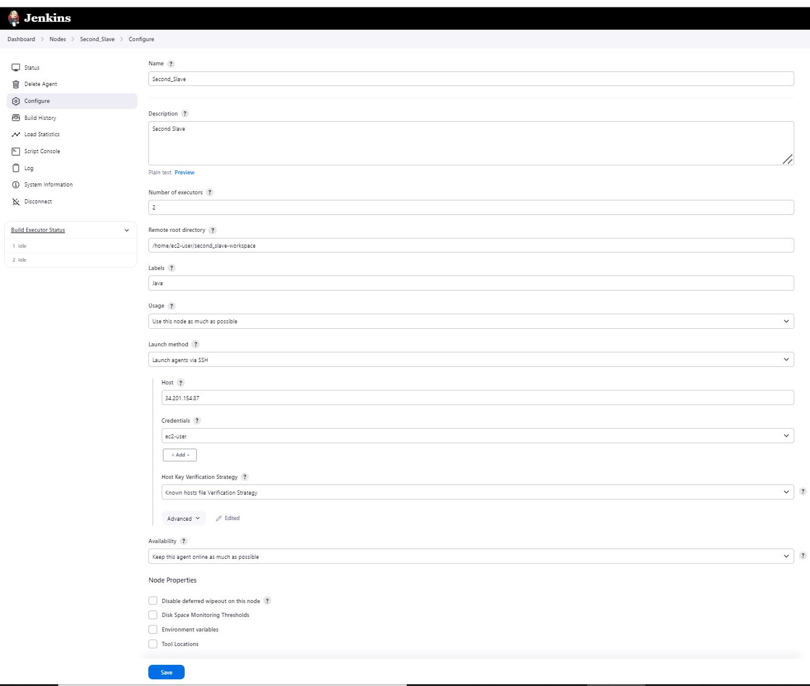

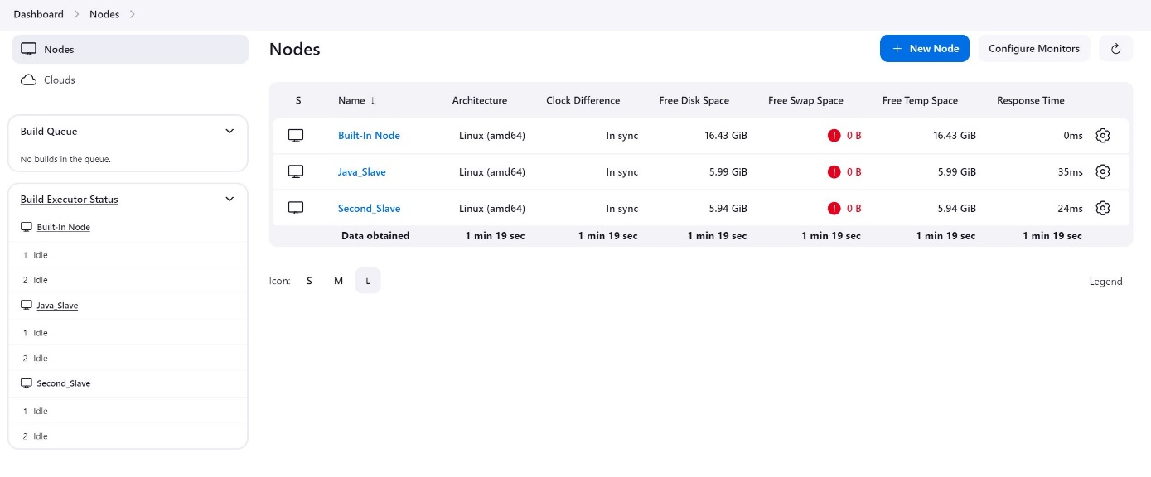

**2) Configure webhooks to jenkins job.**

To create webhooks

* Open github 🡪 Select the repository containing code
* move to settings🡪find webhooks🡪add webhooks
* payloadlink which is combination of Jenkins link and /github-webhook/
* select the even that could the webhook then add webhook

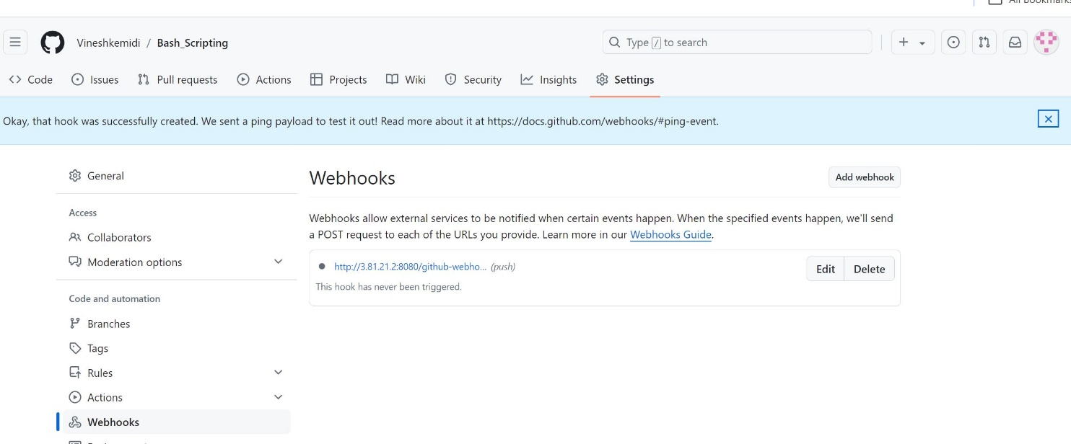

* then move to Jenkins GUI then click on 🡪dashboad🡪managejenkins🡪select job 🡪
* Click on configuration 🡪enable github hook trigger in Build Triggers
* So once done with the above steps if any changes made in code in the selected repo in git
* Automatically a job get triggers

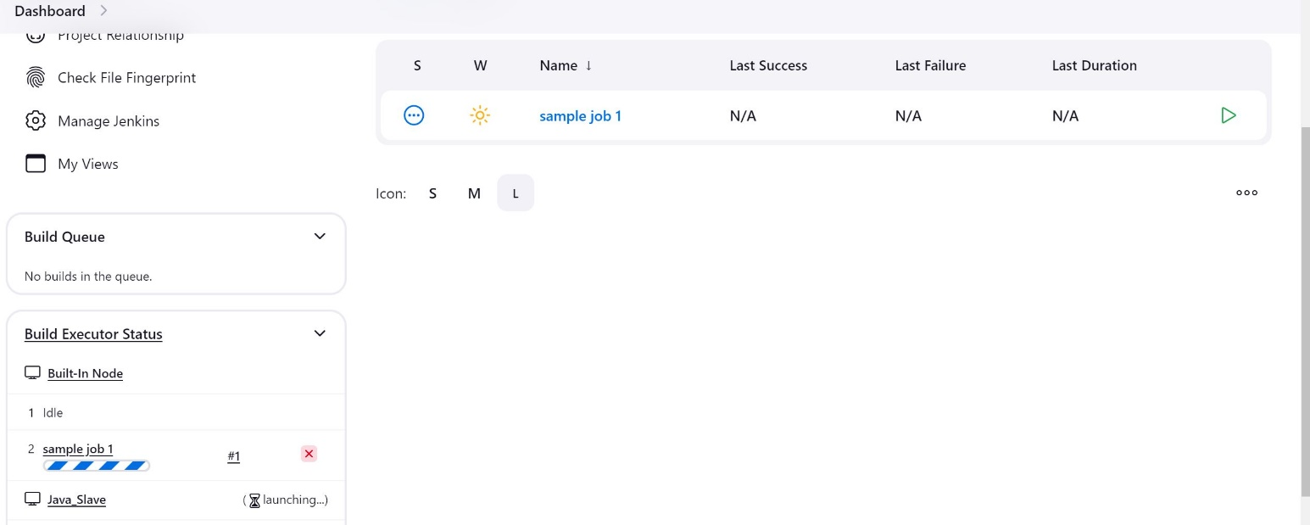

**3) Configure poll scm and build periodical options in jenkins job.**

* **Dashboard 🡪managenjenkins 🡪configuration🡪Build Triggers**

Poll scm is similar to cronjobs

* Poll scm helps us to trigger the job based on our input as * * * * *
* It will check updates in github on specified intervals that we provide and triggers the job
* We need to enable build trigger and give the inputs

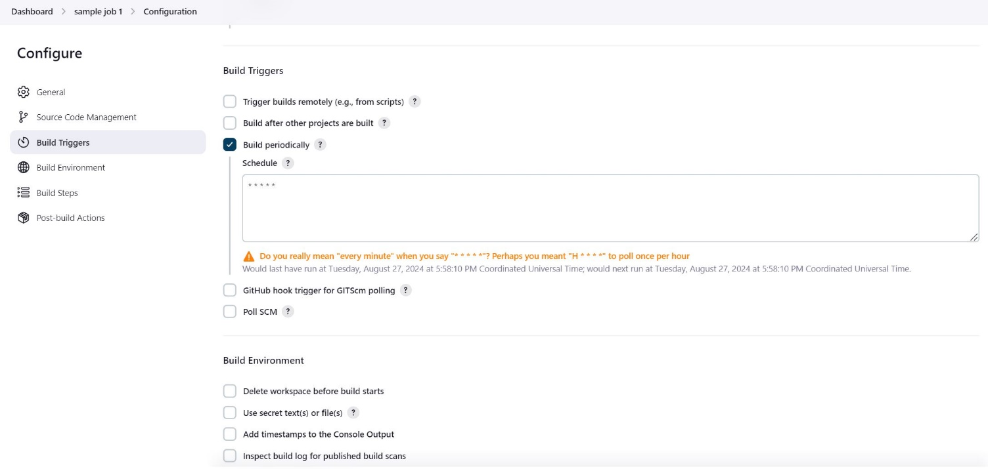

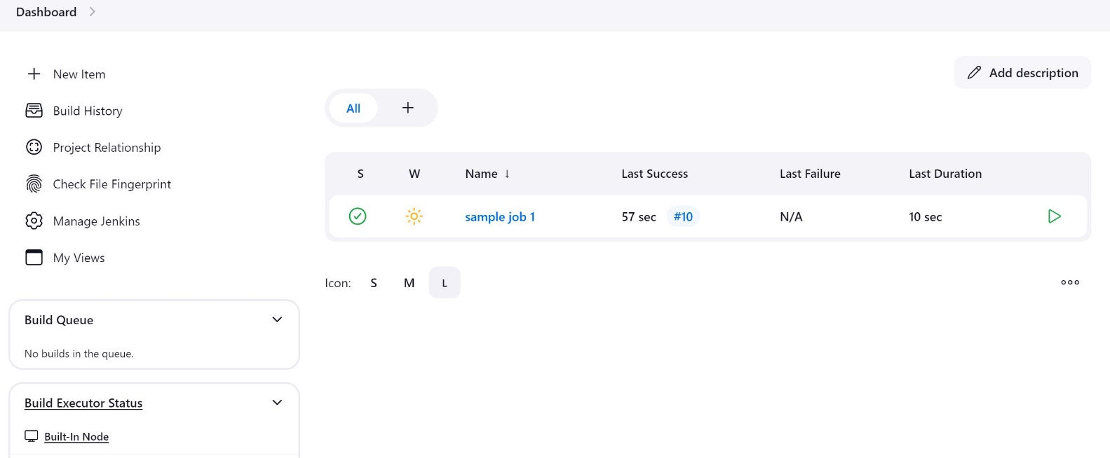

* **Dashboard 🡪managenjenkins 🡪configuration🡪Build Triggers**
* Similar to cronjobs triggers on based on the inputs

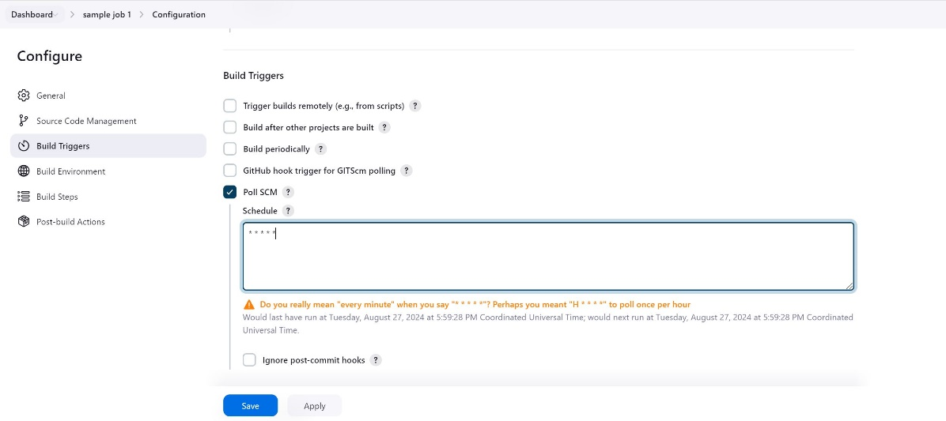

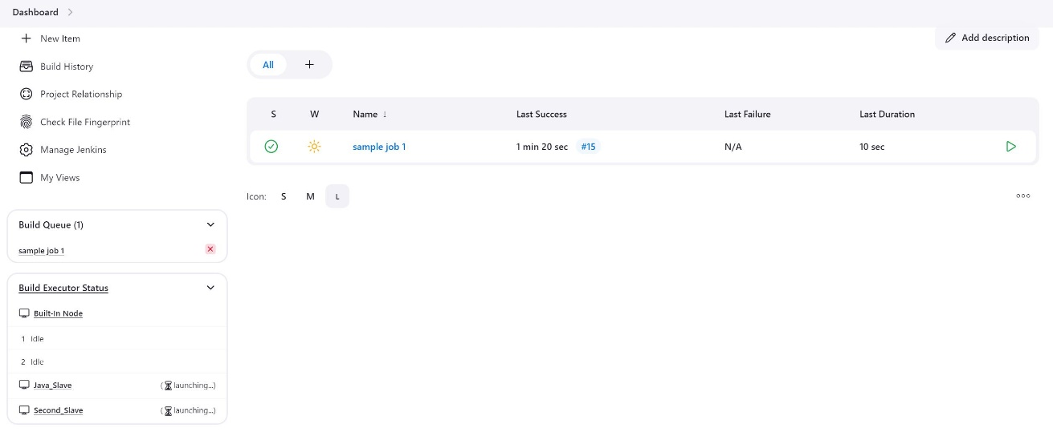

**4) Take backup of Jenkins server by using bash script.**

**#!/bin/bash**

**#Script to take backup of jenkins**

**cd /var/lib/**

**pwd**

**tar cvf jenkins_backup.tar jenkins**

**if [ $? -eq0 ]**

**echo "backup file created"**

**else**

**echo "backup file not created"**

**fi**

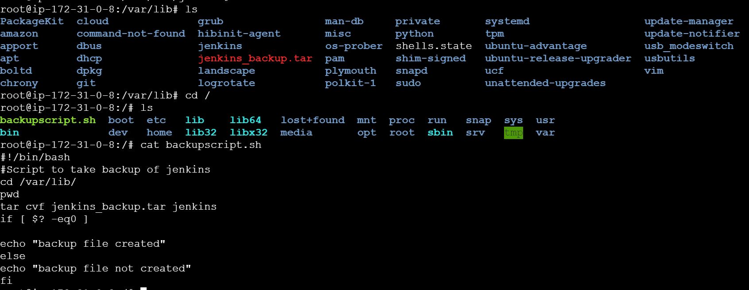

**5) Take backup of Jenkins using rethin backup plugin.**

* **Facing issue with rethin plugin**

**6) Setup a new Jenkins server and dump the backup taken in task4**.

